

**Summer Prep Booklet**

Dear Parent,

This booklet contains an array of activities for your son/daughter to complete over the summer break. It is crucial that students continue to practise their English skills during the holidays and we encourage students to continue using **Accelerated Reader** and **Readtheory.com** in this time.

We will be covering The Hunger Games.

This booklet should be completed over the summer vacation and your child should submit this to their English teacher on their first lesson back.

Kind regards,

Emma Monteith



Head of English

[e.monteith_fps@gemsedu.com](mailto:e.monteith_fps@gemsedu.com)

**Activity 1: What are the features of dystopian fiction?**

**Describe the qualities that make a novel dystopian:**

____________________________________________________________________________________________________________________________________________________________________________________________________________________________________________________________________________________________________________________________________________________________________________________________________________________________________________________________________________________________________________________________________________________________________________________________________________________________________________________________________________________________________________________________________________________________________________________________________________________________________________________________________________________________________________________________________________________________________________________________________________________________________________________________

**Activity 2:**

**Draw and label the features of a dystopian setting**

**Activity 3: Analyse the below extract from The Hunger Games.**

Sixty seconds. That’s how long we’re required to stand on our metal circles before the sound of a gong releases us. Step off before the minute is up, and land mines blow your legs off. Sixty seconds to take in the ring of tributes all equidistant from the Cornucopia, a giant golden horn shaped like a cone with a curved tail, the mouth of which is at least twenty feet high, spilling over with the things that will give us life here in the arena. Food, containers of water, weapons, medicine, garments, fire starters. Strewn around the Cornucopia are other supplies, their value decreasing the farther they are from the horn. For instance, only a few steps from my feet lies a three-foot square of plastic. Certainly it could be of some use in a downpour. But there in the mouth, I can see a tent pack that would protect from almost any sort of weather. If I had the guts to go in and fight for it against the other twenty-three tributes. Which I have been instructed not to do.

________________________________________________________________________________________________________________________________________________________________________________________________________________________________________________________________________________________________________________________________________________________________________________________________________________________________________________________________________________________________

___________________________________________________________________________________________________________________________________________________________________________________________________________________________________________________________________________________________________________________________________________________________________________________________________________________________________________________________________________________________________________________________________________________________

____________________________________________________________________________________________________________________________________________________________________________________________________________________________________________________________________________________________________________

**Activity 4:Language devices**

***Give examples of the following language devices:***

***Simile:_______________________________________________________________***

***Metaphor:____________________________________________________________***

***Personification:_______________________________________________________***

***Hyperbole:___________________________________________________________***

***Juxtaposition:________________________________________________________***

***Sibilance:____________________________________________________________***

***Pathetic fallacy:_______________________________________________________***

***Write a dystopian setting description using all of the abover language devices:***

___________________________________________________________________________________________________________________________________________________________________________________________________________________________________________________________________________________________________________________________________________________________________________________________________________________________________________________________________________________________________________________________________________________________

____________________________________________________________________________________________________________________________________________________________________________________________________________________________________________________________________________________________________________

***Activity 5: Proofreading***

***Circle the correct word from those in the brackets to complete the following short text.***

Mr Francis was the (principle / principal) speaker at the conference. His new role was to (council / counsel) students on financial matters. Everyone was confident that the (advice / advise) he offered would be willingly accepted.

***Find and correct the error in the following sentence.***

Tom smiles as the pink tinged light creeps over the horizon. He stops for a moment to watch the sunrise then lifts his bag and started to walk towards the distant mountains.

**Activity 6: Implied meaning test**

Scan the QR code or follow the link below to take you to a test on implied meaning:



<https://www.cambridgeenglish.org/learning-english/activities-for-learners/c1l002-understanding-implied-meaning>

**Activity 6: Formal and informal writing**

Scan the QR code or follow the link below to take you to a test on implied meaning



<https://www.cambridgeenglish.org/learning-english/activities-for-learners/c1w001-formal-and-informal-writing>

**Activity 7: Word classes: Look/cover/check**

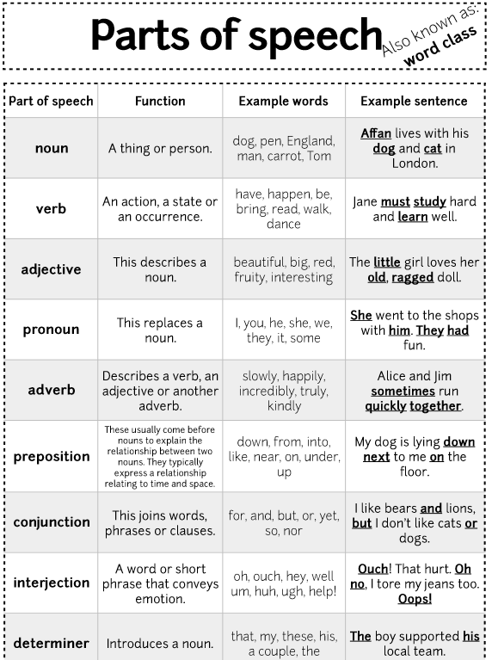

**Read the news article and record any vocabulary you are unsure of in the table below:**



<https://www.khaleejtimes.com/business/economy/Dubais-economic-growth-strengthens-ahead-of-Expo-2020>

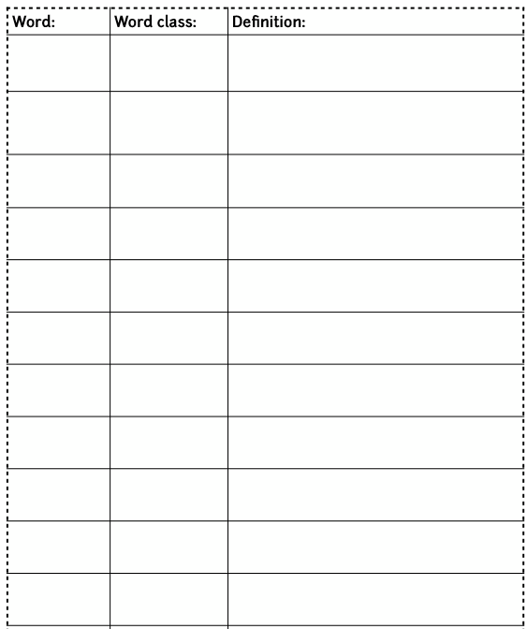

**Activity 7: Summarise the facts and information about Williiam Shakespeare below**



<https://www.bl.uk/people/william-shakespeare>

___________________________________________________________________________________________________________________________________________________________________________________________________________________________________________________________________________________________________________________________________________________________________________________________________________________________________________________________________________________________________________________________________________________________

____________________________________________________________________________________________________________________________________________________________________________________________________________________________________________________________________________________________________________

____________________________________________________________________________________________________________________________________________________________________________________________________________________________________________________________________________________________________________________________________________________________________________________________________________________________________________________________________________________________________________________________________________________________

____________________________________________________________________________________________________________________________________________________________________________________________________________________________________________________________________________________________________________

